Structure Chart for Project 3-Simple Operations

main

getFactorial

withinRange

DisplayReport

performOperations

validateInput

countPrimes

isLeapYear

isPrime

Pseudocode for isPrime:

1.This function takes the given integer and tests if the integer is less than two.

2.If the integer is less than two, then the program will return a false value (indicating the integer is not a prime number). If the integer is equal to two or greater, it then tests if the given integer is divisible by two without a remainder and is not equal to two.

3.Then, if the integer fulfills both conditions the program will return a false value. If the integer fails both conditions, it is then tested whether or not it is divisible by any positive number between 2 and the square root of the given integer.

4.If the integer is divisible by any of these numbers, the program will return a false value. Otherwise, the program will return a true value (indicating the number is prime), as long as it passes all of the above tests.

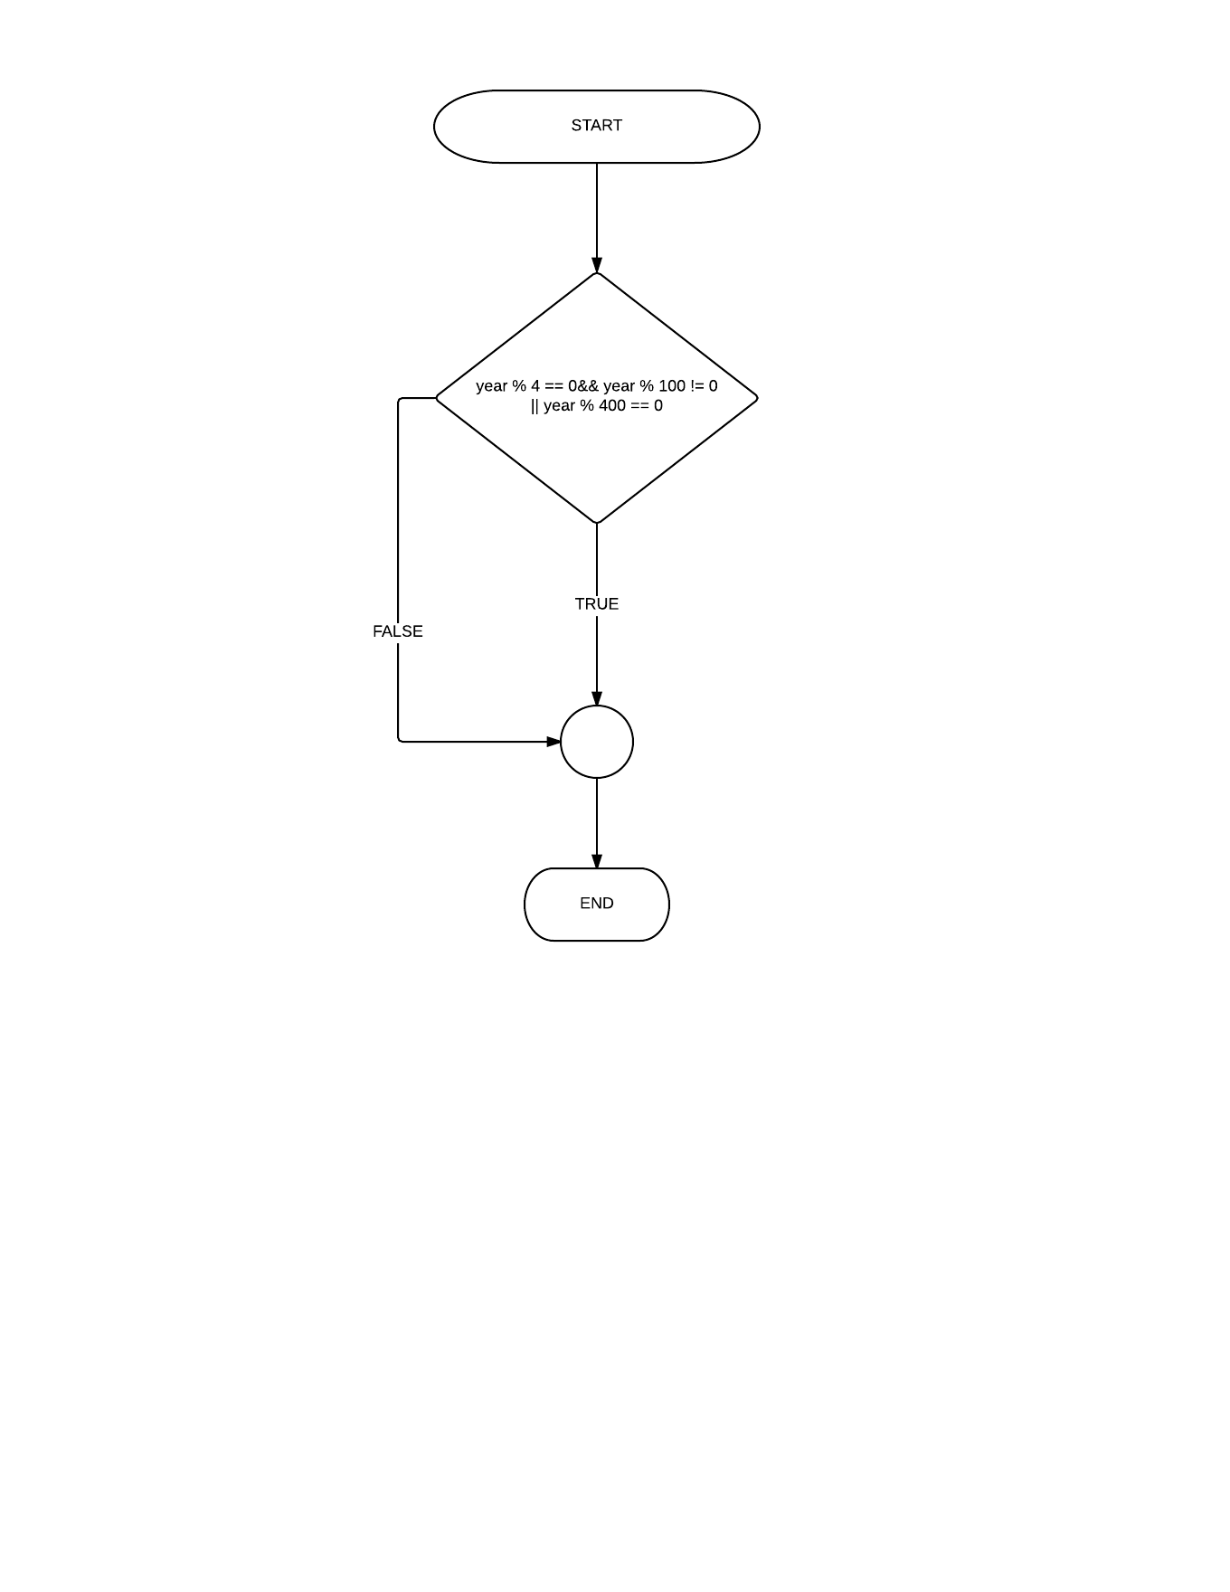

Flowchart for isLeapyear